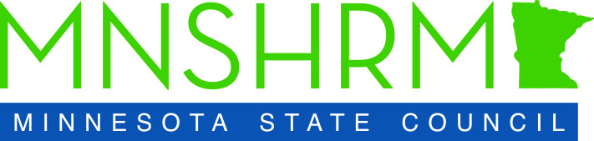

MNSHRM State Conference Agenda
October 9-11, 2022
Mystic Center, Prior Lake, MN

Sunday, October 9
2:00 p.m. – 3:00 p.m. State Council Executive Board Meeting
3:00 p.m. – 4:00 p.m. State Council Meeting
4:30 p.m. – 6:00 p.m. State Council Social Hour and Dinner

________________________________________________________________________________

Monday, October 10
8:00 a.m. – 9:00 a.m. Attendee Arrival and Check-In
9:00 a.m. – 9:15 a.m. Welcome and Announcements
9:15 a.m. – 10:15 a.m. Opening Keynote: Michael S. Cohen
10:15 a.m. – 10:30 a.m. Break/Exhibit Hall
10:30 a.m. – 11:30 a.m. Breakout Session #1
11:30 a.m. – 11:45 a.m. Break/Exhibit Hall
11:45 a.m. – 12:45 p.m. Breakout Session #2
12:45 p.m. – 1:15 p.m. Lunch Transition
1:15 p.m. – 1:30 p.m. Lunch Sponsor Message
1:30 p.m.– 2:30 p.m. Lunch Keynote: John Kriesel
2:30 p.m. – 2:45 p.m. Break/Exhibit Hall
2:45 p.m. – 3:45 p.m. Breakout Session #3
3:45 p.m. – 4:00 p.m. Break/Snack/ Exhibit Hall
4:00 p.m. – 5:00 p.m. Breakout Session #4
5:00 p.m. – 6:00 p.m. Happy Hour/Networking Reception
6:00 p.m. – 9:30 p.m. Dinner/Evening Program
________________________________________________________________________________

Tuesday, October 11
7:30 a.m. – 8:30 a.m. Grab and Go Breakfast
8:30 a.m. – 9:30 a.m. Opening General Session: Panel Discussion
9:30 a.m. – 9:45 a.m. Break/Exhibit Hall
9:45 a.m. – 10:45 a.m. Breakout Session #5
10:45 a.m. – 11:00 a.m. Break/Exhibit Hall
11:15 a.m. – 12:15 p.m. Breakout Session #6
12:15 p.m. – 1:00 p.m. Lunch
1:00 p.m. – 2:00 p.m. Closing Keynote: Johnny C. Taylor, Jr.

*Agenda is subject to change.

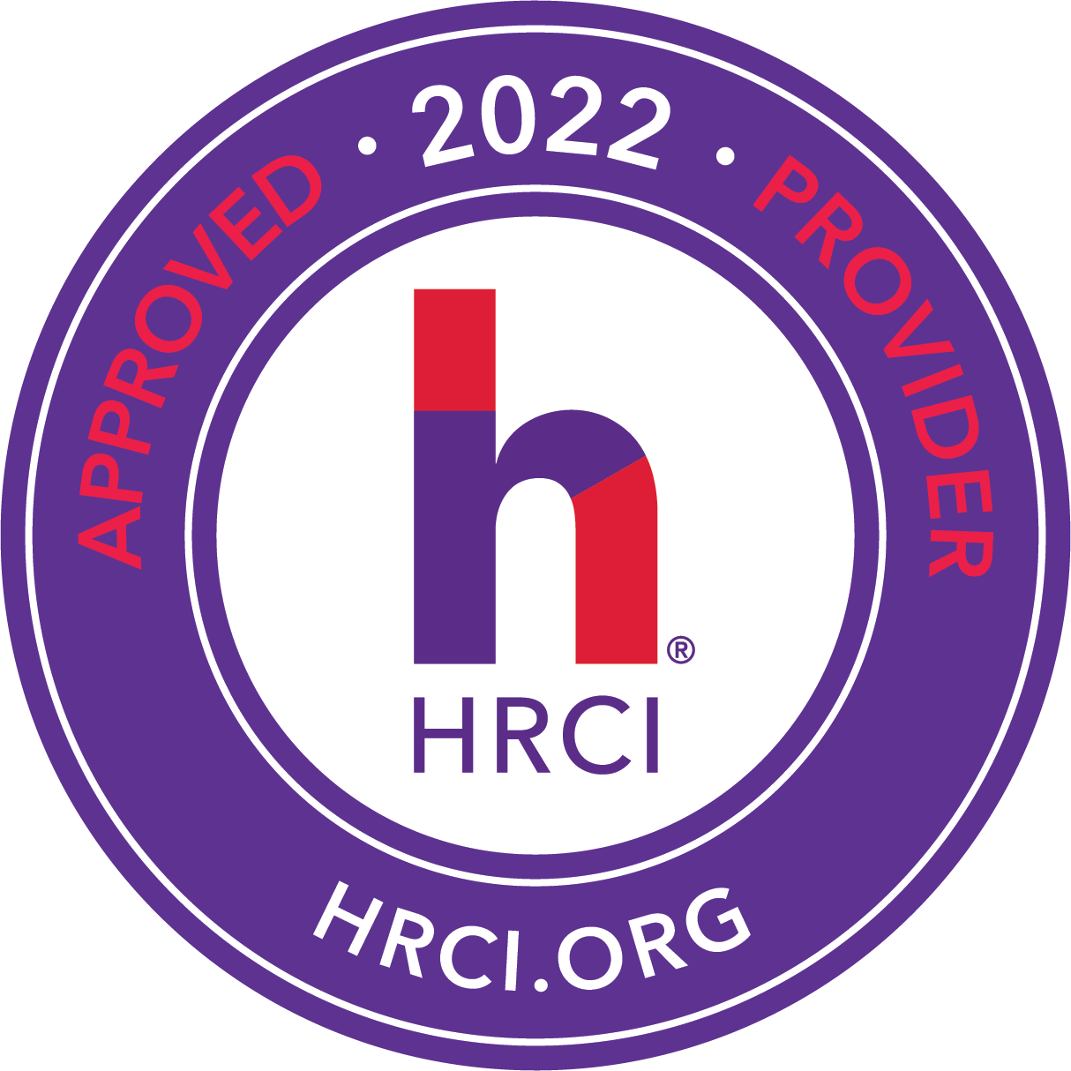
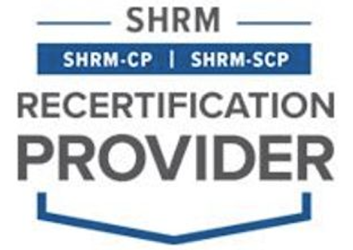
The 2022 State Conference has been approved for 9.75 credits HRCI and SHRM CEU credits and 8 of these sessions have been approved for HRCI business credits.

